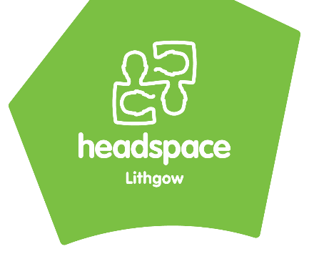
headspace Lithgow Referral Form

Please note criteria for headspace Lithgow to accept this referral:

- Do you believe this young person is at urgent risk of harm to themselves or other people?
☐ Yes ☐ No
IF YES, STOP! If the young person is currently at risk of harm to themselves or to someone else, they are no suitable for headspace services. Please contact the mental health hotline on 1800 011 511 (24 hours) for appropriate services, take them to your nearest hospital, or call 000.

- Is the Young person aged between 12 and 25 years of age?
- Yes

- Is the Young person aware of and consent to this referral being made?
- Yes – verbal consent was given (Date)____________
- Yes – (Client signature) _________________________ (Date)____________
- No – please call our center to discuss

- If the client is under the age of 14, we require consent of both the young person and their parent/guardian.
Is the parent/guardian person aware of and consent to this referral being made?
- Yes – verbal consent was given (Date)____________
- Yes – (parent/guardian signature) _________________________ (Date)____________
- No – please call our center to discuss

Client information….
Young persons name (preferred):
Age: |  |  | DoB:
Gender: |  |  | Pronouns:
Indigenous/Cultural Identity: | ☐ Aboriginal ☐ Torres Strait Islander ☐ Both ☐ Non-Indigenous  ☐ Other: _____________
Language other than English spoken at home: |  |  |  | Interpreter needed?  ☐Yes ☐No
Young person’s Residential Address:
Who with? | ☐ At home with family ☐ Living alone ☐ Homeless  ☐ Staying with friends ☐ supported accommodation ☐ Refuge
Young person’s mobile number: |  | Young person’s Home number:
Young person’s email:

Reason(s) for referral….
What services would you like the young person to access? Please circle
Mental health wellbeing  *This includes the Youth+ Program | ‘  Drug  Alcohol & another drug support | ‘  Drug  Physical and/or sexual health support | Work and Study support
(Yes / No / Unsure) | (Yes / No / Unsure) | (Yes / No / Unsure) | (Yes / No / Unsure)

Presenting Issues/Reason for referral: Please attach any relevant assessment notes, and/or discharge summaries

Any previous mental health support / treatment, counselling, medication or diagnoses?

What does the young person feel would be useful about coming to headspace, what are their goals? How motivated are they to come?

Any other information that may be relevant? (e.g. family history of mental health issues, client history, court involvement, disability)

Safety considerations (please note these are not exclusion criteria)….
Suicidal ideation? ☐ yes ☐ no  Details: | Substance use? ☐ yes ☐ no  Details:
Non-accidental self-injury? ☐ yes ☐ no  Details: | Risk talking and/or impulsive behaviour? ☐ yes ☐ no  Details:

Additional details….
Does YP have a GP? Doctors name:
Medical centre / Practice:
Is there a current Mental Health Treatment Plan? | ☐ yes ☐ no
Does the young person have an NDIS plan? | ☐ yes ☐ no
Any other workers/services involved?

Name of parent/guardian:
Parent/guardian contact number:
best person to contact about this referral: | ☐ Young person ☐ Parent/Guardian ☐ Referrer
When would be the best time to contact this person?

Referrers details….
Name: | Position / Organization:
Email: | Best contact number:
_______________________ ________________________ ___________
Referrer name Referrer signature Date

