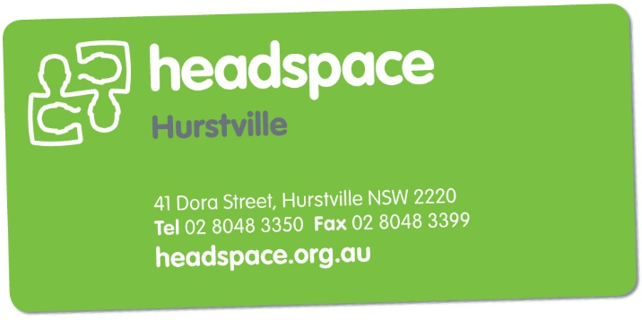
headspace Hurstville
Service Provider

Referral Form

[Select Date]

Please fax referral to 02 8048 3399 or email to headspace.hurstville@aftercare.com.au
Please ensure all sections are completed, UPPERCASE and legible.
Our Intake Officer currently works Wed- Friday and can be reached on 02 8048 3350.
Please note that we are NOT A CRISIS SERVICE. If crisis assistance is required, please call the NSW Mental Health Triage on 1800 011 511. Alternatively, direct your YP to an accident & emergency department of their nearest hospital.
Has the Young Person (YP) consented to referral? | Yes |  | If “NO” referral cannot be accepted.
If the YP is under 16 years & living with parents/carers,  are they aware? |  |  |  | Yes |  | No |  | N/A

YOUNG PERSON’S DETAILS:
First Name: |  |  |  |  |  |  |  |  |  |  | Surname:
Preferred Name:
DOB: |  |  |  |  |  |  |  |  |  |  | Age: |  |  |  |  |  | Gender:
Street Address:
Suburb: |  |  |  |  |  |  |  |  |  |  |  |  |  |  |  |  | Post Code:
Home Phone: |  |  |  |  |  |  |  |  |  |  |  |  |  |  |  |  | Can We Leave a Msg:
Mobile: |  |  |  |  |  |  |  |  |  |  |  |  |  |  |  |  | Can We Leave a Msg:
Email:
Can we post letters to the above address? |  |  |  |  |  |  |  |  |  |  |  |  |  |  |  |  | YES |  |  |  |  | NO |  |  | UNKNOWN
NEXT OF KIN (NOK) DETAILS:
Name:
Relationship:
Street Address: |  |  | As Above
Suburb: |  |  |  |  |  |  |  |  |  |  |  |  |  |  |  |  | Post Code:
Phone: |  |  |  |  |  |  |  |  |  |  | Mobile:
Can we contact NOK? |  |  |  |  |  |  |  |  |  |  |  |  |  |  |  |  | Yes |  |  |  |  |  | Emergency Only
REFERRER’S DETAILS:
Name of referrer:
Relationship to YP:
Organisation Name:
Street Address:
Suburb: |  |  |  |  |  |  |  |  |  |  |  |  |  |  |  |  |  | Post Code:
Phone: |  |  |  |  |  |  |  |  | Fax: |  |  |  |  |  |  |  |  | Mobile:
Email:
Would you like to attend the initial appointment? |  |  |  |  |  |  |  |  |  |  |  |  |  |  |  |  | YES |  |  |  |  | NO |  |  | UNKNOWN
YOUNG PERSON’S MEDICAL INFORMATION
Does the YP have their own GP? |  |  |  |  |  |  |  |  |  |  |  |  |  |  |  |  | YES |  |  |  |  | NO |  |  | UNKNOWN
Details (name, practice, address, phone):
Has the YP ever received prior Mental Health care or has had other worker involved in their care? |  |  |  |  |  |  |  |  |  |  |  |  |  |  |  |  | YES |  |  |  |  | NO |  |  | UNKNOWN
Details (please list service & duration):
Does the YP have a Mental Health Care Plan? |  |  |  |  |  |  |  |  |  |  |  |  |  |  |  |  | YES |  |  |  |  | NO |  |  | UNKNOWN
Date:
Medicare Number: |  |  |  |  |  |  |  |  |  |  |  |  |  |  |  |  | EXP: |  |  |  |  |  |  |  | REF:
YOUNG PERSON’S CULTURE:
Aboriginal |  | Torres Strait Islander |  |  |  |  |  |  |  | Both |  |  |  |  | Neither |  |  |  |  |  | Not Stated |  |  |  |  | Refugee
Family of origin/nationality:
Risk of homelessness? |  |  |  |  | YES |  |  |  |  |  |  | NO

REFERRAL DETAILS:
What is the main concern regarding this young person?
What does the YOUNG PERSON see as the problem?
Duration of the current problem:
Current Risk Taking (suicide, self-harm, homicide, risk taking behaviours, drug & alcohol as well as any relevant history or past attempts):
Further details relevant to presenting problem (lives with, mood, appetite, sleep, home environment, education/employment, relationships)
What assistance would you like from headspace Hurstville?

The referrer agrees that all information submitted in this referral is an accurate reflection of the client’s support needs, is correct with no information withheld for the organization to fulfil its duty of care to clients, staff and other partner agencies.
Referrer signature: _________________________________________________ Date: ___________________________

