Youth Reference Group Application Form
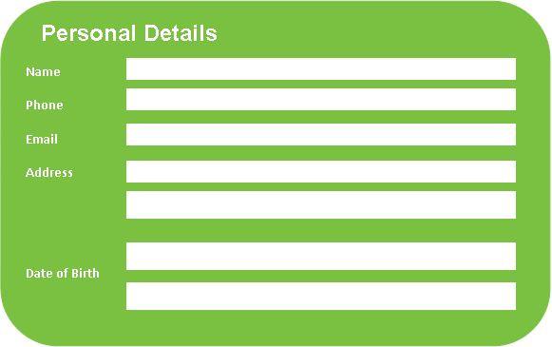

What languages do you speak at home?

Where were you born?

Are you Aboriginal or Torres Strait Islander?

Are you from a rural or remote area?

Do you have a family member with a mental illness?

Do you identify as having/had a mental illness?

If yes, is this something that you would be happy (and feel comfortable) talking about?

About You (Don’t stress! We value your experiences and thoughts)

Please tell us a bit about yourself?
(For example: I am 15 years old, and attend alternative education centre 3 days a week, I like skate-boarding etc)

Why do you want to be involved with headspace? Please describe why you are interested in becoming a Youth Reference Group member?

What type of headspace activities would you like to be involved in?

What skills and ideas could you bring to the Youth Reference Group?

Are you involved in any other organisations? If yes, which ones and what is your involvement?

Please describe some of the mental health issues you think affect young people today?

What type of headspace activities would you like to be involved in?

Do you find change easy or difficult? How do you manage that?

Do you see yourself as able to participate in a group consultation process, or will you need training to do this?

Tell us about the strategies you will use to balance schools/work/YRG commitments?

Will you be able to travel to and from meetings/events: YES NO
Are you able to work flexible hours? YES NO
Send to Rachel.Adams@health.nsw.gov.au and Cc: Silas.Pollard@health.nsw.gov.au

