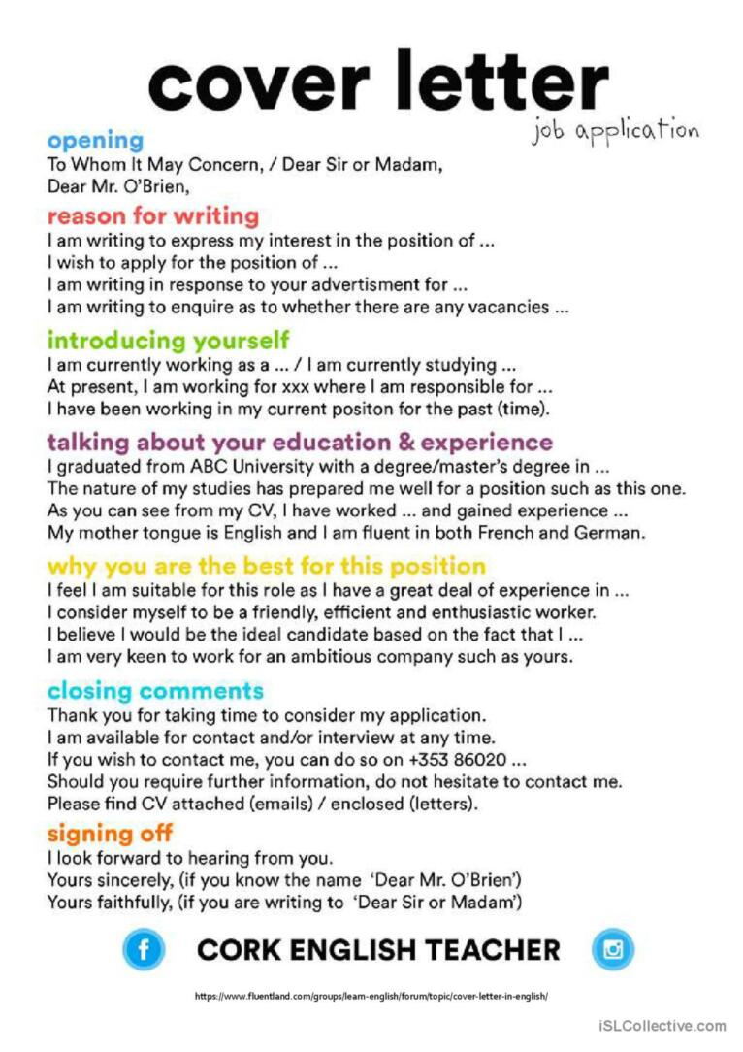

Example

Dear Sir or Madam,

I am writing to express my interest in the position of Barista at the coffee shop as advertised on seek.com

I am currently working at the fast-food place and have been in this position for 2 years. As you will see from my resume, I have worked at predominantly in the hospitality industry and will bring my valuable experience to the new role. I am also currently studying a degree at 123 university, and I am in my second year of a 3-year degree.

I feel I am very suitable for this role, as I am a bubbly and friendly person, who excels in a customer focussed position. I am a quick learner, and keen to expand on my existing skillset.

Thank you for taking the time to consider my application, please find my resume attached

I look forward to hearing from you soon.

Joe Blogs
1234 567 890

